1. **Arduino UNO platform ------- avoid_ultrasonic**
2. **Preparation**

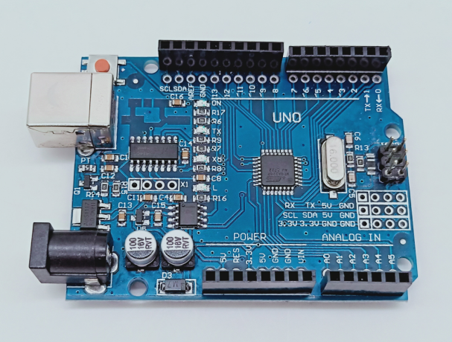

1-1 Arduino UNO board

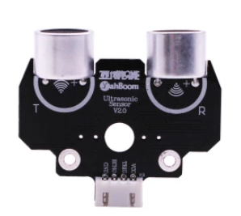

1-2 Ultrasonic module

**2)Purpose of Experimental**

After the code upload is completed, you need to press the K2 to start the car, and the ultrasonic obstacle avoidance function is started. When there is an obstacle in front, the car can avoid the obstacle automatically.

**3)Principle of experimental**

The ultrasonic module is a sensor that uses ultrasonic characteristics to detect the distance. It has two ultrasonic probes for transmitting and receiving ultrasonic waves. The range of measurement is 3-450 cm.

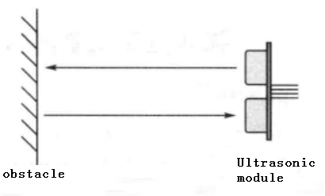

3-1 Ultrasonic emission and reception schematic

(1) You need to input a high level signal of at least 10us to the Trig pin to trigger the ranging function of the ultrasonic module.

3-2 Ultrasonic module sends trigger signal

1. After the ranging function is triggered, the module will automatically send out 8 ultrasonic pulses with 40 kHz and automatically detect whether there is a signal return. This step is done internally by the module.



1. When the module detects an echo signal, the ECHO pin will output a high level. The high level duration is the time from when the ultrasonic wave is sent to when it returns. You can calculate the distance by using the time function to calculate the high level duration. Formula: Distance = High level duration * Speed of sound(340M/S)/2.

**4)Experimental Steps**

4-1 About the schematic

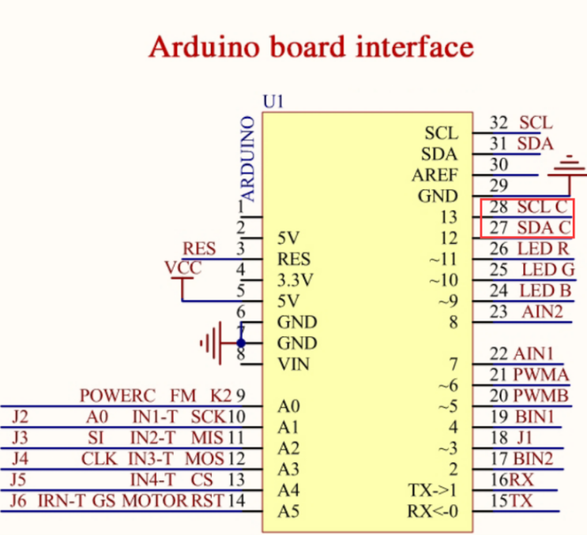

4-1 Arduino UNO interface circuit diagram

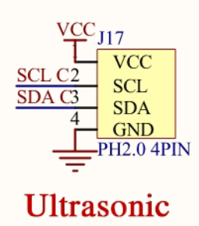

4-2 ultrasonic interface

4-2 According to the circuit schematic:

Trig-----SCL----- 13(Arduino UNO)

Echo-----SDA-----12(Arduino UNO)

4-3 About the code

1. We need to open the code of this experiment:**avoid_ultrasonic.ino**, click“**√**” under the menu bar to compile the code, and wait for the word "**Done compiling** " in the lower right corner, as shown in the figure below.

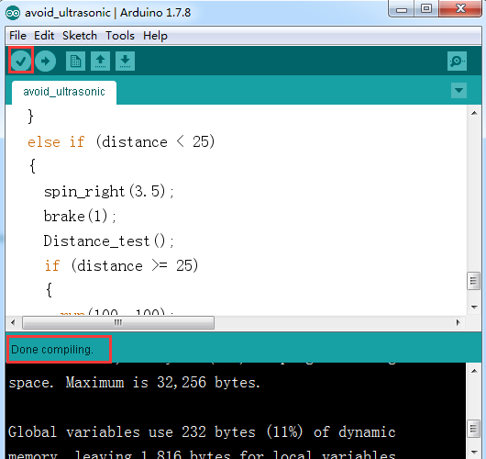

2.In the menu bar of Arduino IDE, we need to select 【Tools】---【Port】--- selecting the port that the serial number displayed by the device manager just now, as shown in the figure below.

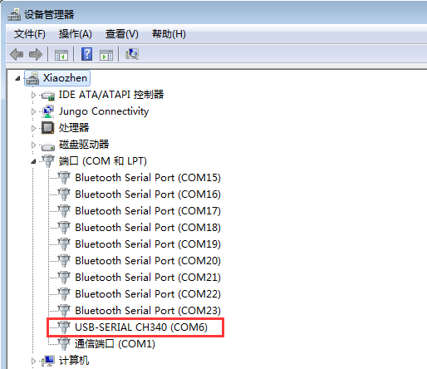

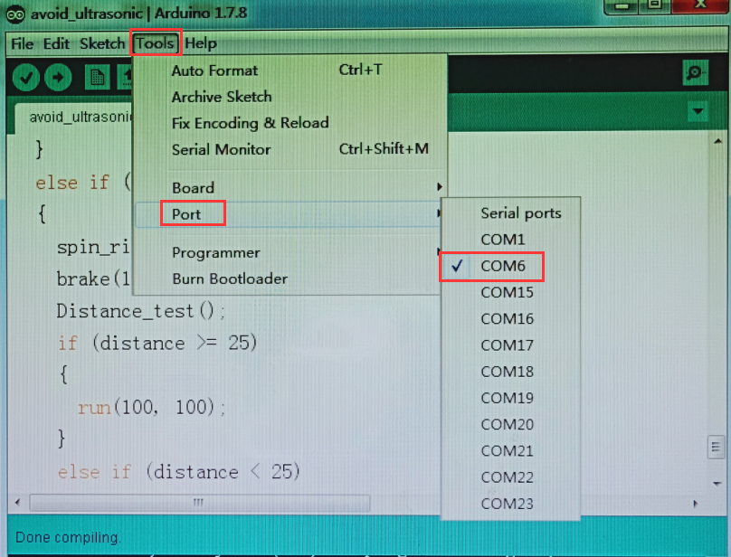

3.After the selection is completed, you need to click “**→**”under the menu bar to upload the code to the Arduino UNO board. When the word “**Done uploading**” appears in the lower left corner, the code has been successfully uploaded to the Arduino UNO board, as shown in the figure below.

